**Screen Shots**

**1.Intial Menu**

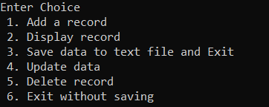

**2.Adding a Record**



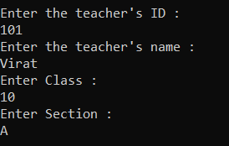

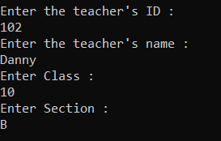

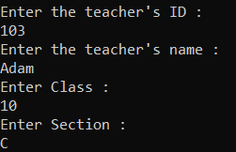

**Above steps will add 3 teachers data into record**

**3.Displaying the record**

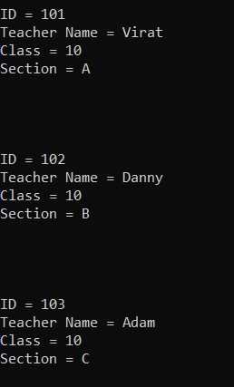

**4.Updating Teachers record**

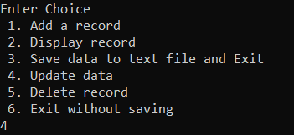

**The user will have to enter Teacher’s ID**



**The user will get the following options to update(ID exits)**

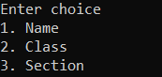

**Below the user has opted for 2nd option**



**Before(Left) and After updating the data**

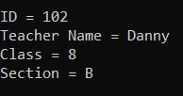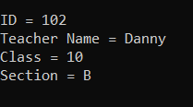

**If the ID is not found in records, then the script will throw an error message as shown below.**

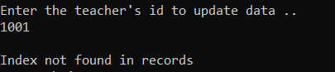

**5.Deleting a Record**

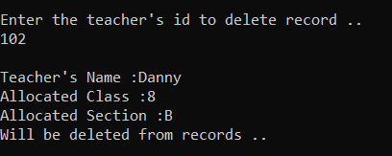

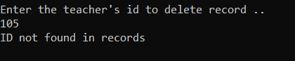

**6.User can exist without saving the data**

